**Instruction for self-registration of the supplier**

Contents

1. Introduction 3

2. General information about self-registration 3

2.1. The structure of the form of self-registration 6

2.2. Introductory information 6

2.3. General company information 8

2.4. Legal address 10

2.5. Postal address 11

2.6. Bank details 12

2.7. Electronic workflow 13

3.8. Contact details 14

3.9. Product categories 15

3.10. Attachments 17

3.11. Agreement to the storage and processing of my personal data 18

4. Completion of supplier registration 19

5. Automatic password / login recovery 21

# Introduction

To get access to the procurement management system, you should complete the self-registration procedure. This document describes the process of self-registration: describes the actions that allow a potential supplier to submit an application for registration in the procurement system of PJSC SIBUR Holding.

# General information about self-registration

To work successfully, the system should have one of the following Internet browsers installed: Microsoft Internet Explorer version 11.0 or above, Mozilla Firefox version 65 or above, Google Chrome version 71 or above.

To start self-registration, a potential supplier should follow the link ( <https://srm.sibur.ru/sreg/>).

After clicking on the link, a self-registration form will open, which is divided into 2 stages:

* Filling out your company identity (see figure 1)
* Filling Company Information

The transition to the second stage is carried out only after filling in the fields in the first stage.

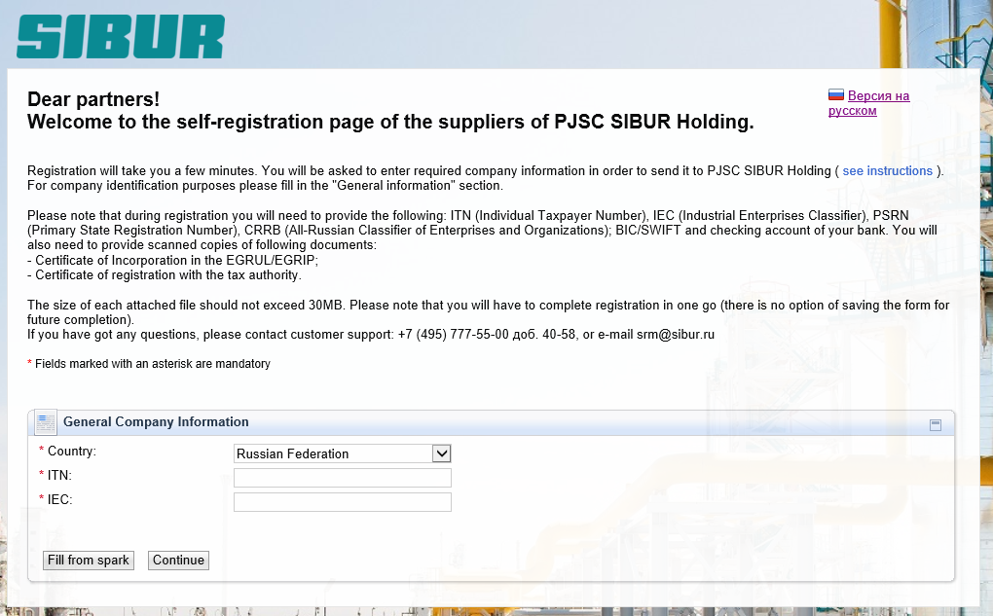

Figure 1*. Stage 1 of filling in the registration form*

In stage 2, you need to fill out the following sections

* General Company Information
* The contact person
* Product Categories
* Attachments

For successful registration in the system, the potential supplier will need the following data:

* Registration number
* Registration date
* Issuing authority
* BIC/SWIFT of bank
* Checking account

It should also be noted that **it is impossible to save the partially completed registration form**, so please prepare all the documents and have all the information available.

Fields marked with a symbol (*) are required. **A form with empty required fields cannot be sent.** The remaining form fields are optional to provide more detailed information about your company.

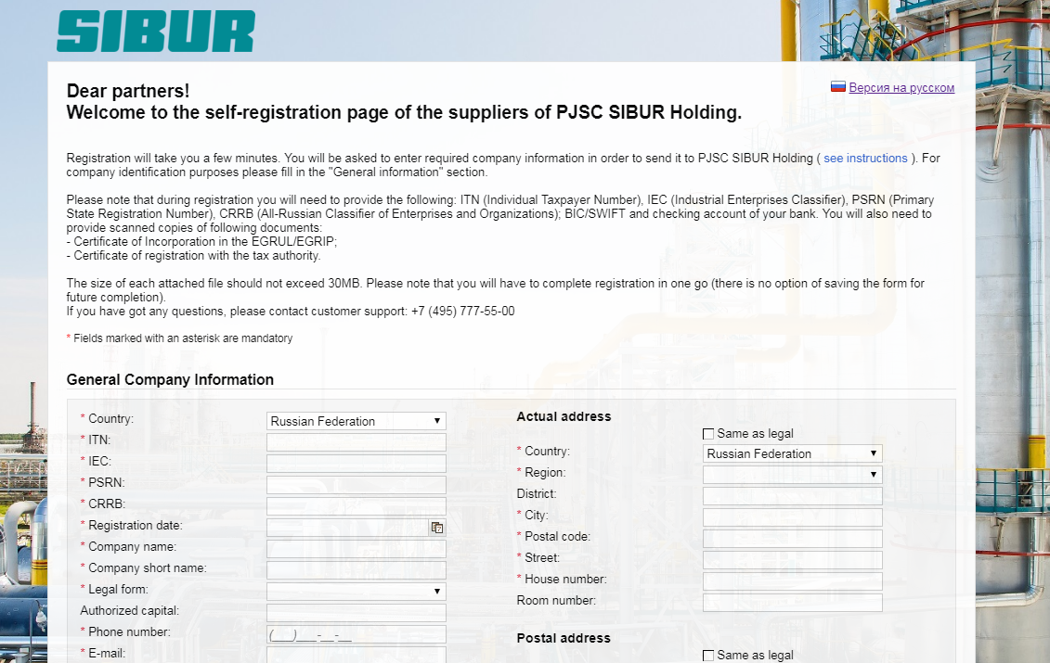

Figure 1

If you have filled in the data that is already in the system, the system will display an error stating that the company has already been registered. In this case, you need to contact support at +7 (495)777-55-00 (ext. 40-58)

The result of the self-registration process is a completed and successfully submitted form. After processing the form, the system will send a decision on the approval or rejection of registration. **Information about the decision will be sent by e-mail to the address specified in the E-mail box in the Contact Details.**

The ability to click on the send button appears after filling in all the required fields, correctly specified information and the flag in the block « Agreement to the storage and processing of my personal data ».

**If you have any questions, please contact the support service by phone +7 (495) 777-55-00 (ext. 40-58)**

Next will be described in detail the structure of the self-registration form.

# The structure of the form of self-registration

## Introductory information

At the beginning of the form, you are provided with introductory information. The introductory information contains a list of mandatory documents that you need to have with you when you start registration.

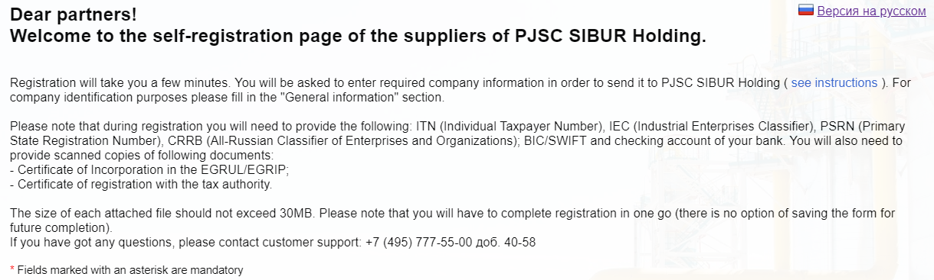

Figure 2

At the first stage, it is necessary to indicate the country of the Company (select from the list), as well as indicate the TIN and PPC.

*Figure 3 Registration Data Entry.*

After entering the TIN and PPC, you must go to the second stage of filling out the registration form. In the system, it is possible to go to the second stage with automatic completion of registration form data from the SPARK Interfax system. To do this, press the button.

Fields filled in automatically (from SPARK) will not be editable. The SPARK number will be displayed on the application registration form. The functionality for filling data from SPARK is available only for the country “Russian Federation”.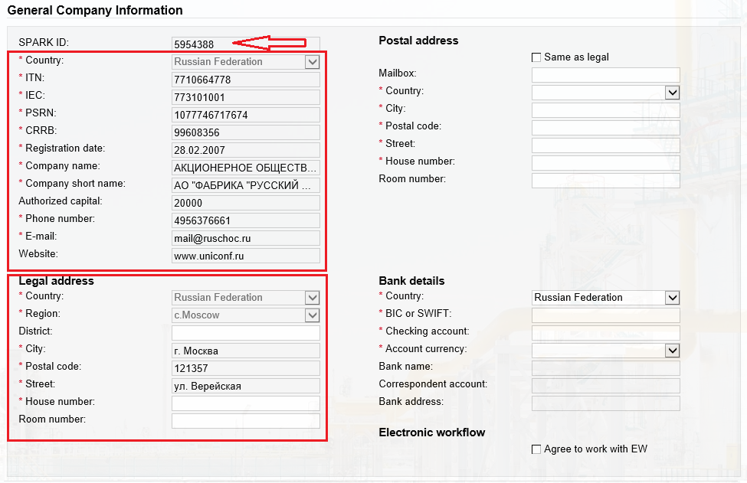

*Figure 4 Filling in the fields from SPARK*

To manually fill out the registration form, click .



Figure 3

For a successful self-registration, you need to eliminate the errors, and then repeat the attempt to send the form by clicking the "Send" button.

## General company information

In the “General company information” section, you must fill in the basic information about the company.

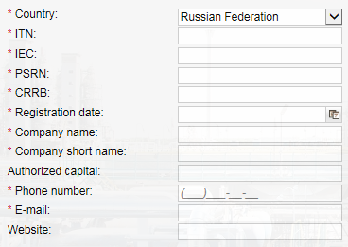

Figure 4

When specifying the country, the Russian Federation block “General company information” has the following fields:

1. Country

You should select the country of the company from the list (mandatory field).

1. ITN

Identification Taxpayer Number (mandatory field).

You should specify the correct number.

1. IEC

Code of the reason for registration (mandatory field).

You should specify the correct code.

1. PSRN

Primary state registration number (mandatory field).

You should specify a valid number.

1. CRRB

The organization code in the all-Russian classifier of enterprises and organizations (mandatory field).

You should specify the correct code.

1. Registration date

Date of registration of the company (mandatory field).

The date is indicated in the dd.mm.yyyy format.

1. Company name

Full company name (mandatory field).

1. Company short name

You should specify the abbreviated name of the company (mandatory field).

1. Legal form

Provides a choice of possible legal forms (mandatory field).

1. Authorized capital:

Specifies the size of the share capital in rubles.

1. Phone number

You should specify the phone number of the company (mandatory field).

It is necessary to fill in the phone number of the person without 8 or the country code, but with the city code. In the format (xxx) xxx-xx-xx

1. E-mail

Email address of the company (mandatory field).

You should specify a valid email.

1. Website

Company website.

When specifying a country other than the Russian Federation in the “General company information” block, the fields are changed:

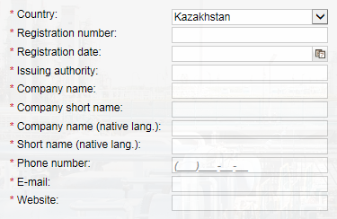

Figure 5

1. Country

You should select the country of the company from the list (mandatory field).

1. Registration number

Registration number (identification number) of the company, adopted in the country of registration (mandatory field).

1. Registration date

Date of registration of the company (mandatory field)

The date is indicated in the dd.mm.yyyy format.

1. Issuing authority

You should specify the company registration authority (mandatory field).

1. Company name

Full company name (mandatory field).

1. Company short name

You should specify the abbreviated name of the company

1. Company name (native lang.)

The full name of the company in your native language.

1. Short name (native lang.)

You should specify the abbreviated name of the company in your native language (mandatory field).

1. Phone number

You should specify the phone number of the company (mandatory field).

It is necessary to fill in the phone number of the person without 8 or the country code, but with the city code. In the format (xxx) xxx-xx-xx

1. E-mail

Email address of the company (mandatory field).

You should specify a valid email.

1. Website

You should specify the company website (mandatory field).

## Legal address

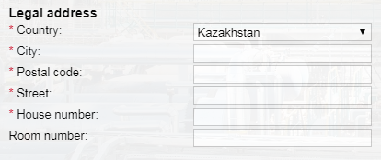

Figure 6

In the "Legal Address" block you need to fill in the information on the legal address of the company. When choosing the Russian Federation, this block is supplemented with the fields “District” and “Region”.

1. Country

It is necessary to choose from the list the country of the legal address (mandatory field).

1. City

You should specify the city of the legal address (mandatory field).

1. Postal code

You should specify the postal code of the legal address (mandatory field).

1. Street

You must specify the street of the legal address (mandatory field).

1. House number

The house number of the legal address. (mandatory field)

1. Room number

Room number of the home legal address.

## Postal address

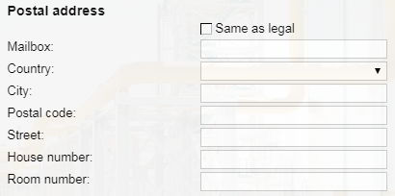

Figure 8

In the "Postal address" block you need to fill in the information about the postal address of the company.

1. Flag «Same as legal»

It is necessary to put a flag if the actual address of the company coincides with the legal address. After which the fields in the block the actual address will become unavailable.

1. Country

It is necessary to choose from the list the country of the legal address.

1. City

You should specify the city of the legal address.

1. Postal code

You should specify the postal code of the legal address.

1. Street

You must specify the street of the legal address.

1. House number

The house number of the legal address.

1. Room number

Room number of the home legal address.

## Bank details

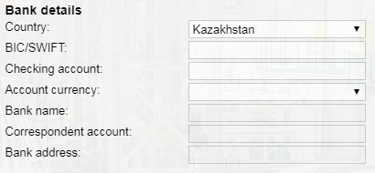

Figure 9

In the "Bank data" block you need to fill in information about the company's banking data. For non-residents entering data about the bank is not mandatory.

1. Country

You should select a bank country from the list.

1. BIC/SWIFT

Bank Identifier Code/ Society for Worldwide Interbank Financial Telecommunication (SWIFT).

You should specify the correct code.

1. Checking account

You should specify the company's current account number.

1. Account currency

You should specify the bank account currency

1. Bank name

Name of the bank.

It is automatically filled in when the BIC / SWIFT bank field is filled in correctly. If the automatic filling of the fields did not occur, you must contact the support by phone +7 (495) 777-55-00 (ext. 40-58)

1. Correspondent account

Correspondent bank account.

Name of the bank.

It is automatically filled in when the BIC bank field is filled in correctly. If the automatic filling of the fields did not occur, you must contact the support by phone +7 (495) 777-55-00 (ext. 40-58)

1. Bank address

Bank address.

It is automatically filled in when the BIC bank field is filled in correctly. If the automatic filling of the fields did not occur, you must contact the support by phone +7 (495) 777-55-00 (ext. 40-58)

## Electronic workflow

In the “Electronic workflow” block it is necessary to put the flag “I agree to work with EW” if the company agrees to work through electronic workflow. After setting the flag "I agree to work on the EDI" additional fields appear that must be filled.

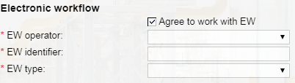

Figure 10

1. EW operator

Operator of electronic document circulation (mandatory field).

A choice of three values is substituted:

* Diadoc
* Esphere courier
* Sbis

**If you are using another operator, please do not fill out this section.**

1. EW identifier

The unique code of your organization for the selected EW operator (mandatory field).

1. EW type

Type of electronic document flow (mandatory field).

A choice of three values is substituted:

* All documents
* Contract
* Source documents

## Contact details

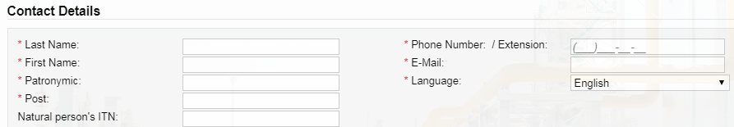

Figure 11

In the block "Contact details" you need to fill in the information about the company representative. Please note that the registration data will be sent to the email address specified in this section. If possible, please specified your work address, do not use personal addresses, do not use non-existent addresses, as in this case you will not be able to register.

1. Last name

You should specify the last name of the person (mandatory field).

1. First name

You should specify the first name of the person (mandatory field).

1. Patronymic

You should specify the patronymic of the person (mandatory field).

1. Post

You should specify the position of the person (mandatory field).

1. Natural person’s ITN

Taxpayer identification number of the contact person.

1. Phone number / Extension

You should fill in the phone number of the person without 8 or the country code, but with the city code (required field). If necessary, you can fill the internal (extension) number.

1. E-mail

You should specify the email address of the person (mandatory field).

1. Language

You should select a language from the list (mandatory field).

For non-residents, the “Contact Details” block looks like this:

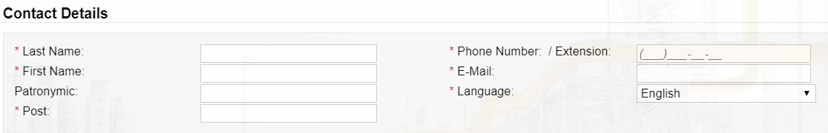

Figure 12

1. Last name

You should specify the last name of the person (mandatory field).

1. First name

You should specify the first name of the person (mandatory field).

1. Patronymic

You should specify the patronymic of the person.

1. Post

You should specify the position of the person (mandatory field).

1. Phone number / Extension

You should fill in the phone number of the person without 8 or the country code, but with the city code (required field). If necessary, you can fill the internal (extension) number.

1. E-mail

You should specify the email address of the person (mandatory field).

1. Language

You should select a language from the list (mandatory field).

## Product categories

This block allows the supplier to choose a category or several categories of materials, works and services that he plans to supply for PJSC SIBUR Holding.

To select the categories that you plan to deliver, you should click on the "Add" button.

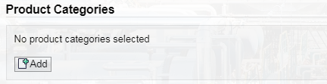

Figure 13

A list will open, which is a catalog of possible categories of products and services of PJSC SIBUR Holding.

In the window that opens, you can find the appropriate category (s) by searching. To do this, you need to write search keywords (for example, “fuel” or “bearings”, etc.) and options will be offered.

If no options were found, then it is necessary to find a suitable category in the catalog. To select the appropriate categories, click on the checkbox to the left of the category name. Moreover, if you select a top-level category (that is, including several categories within yourself), then all categories within will also be selected.

After selecting all the appropriate categories, you should click on the "ok" button at the bottom of the screen.

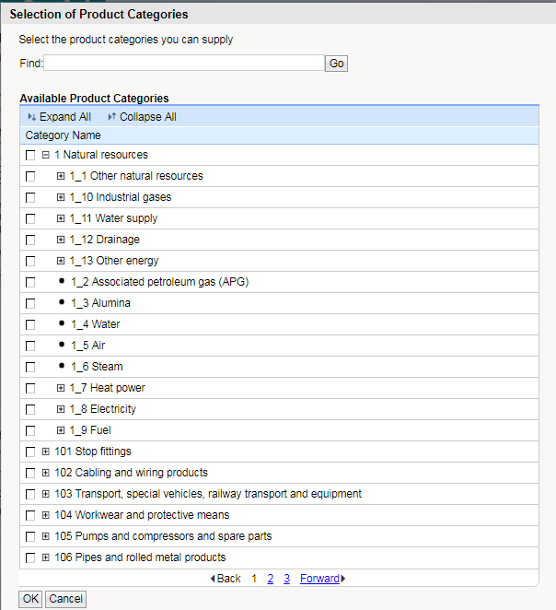

Figure 14

After selecting product groups, you will see the list of categories on the screen. If necessary, you can edit, removing unnecessary categories or adding the necessary ones.

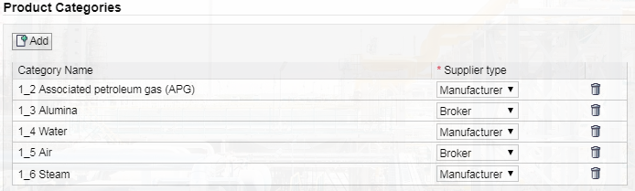

Figure 15

For each product category, you must specify the type of supplier (manufacturer, broker).

## Attachments

This block allows the supplier to attach files to the self-registration form.

For resident of the Russian Federation, it is necessary to attach a scanned copy of the certificate from the Unified State Register of Legal Entities / Unified State Register of Individual Entrepreneurs.

For a resident of the Russian Federation, it is necessary to attach a scanned copy of the certificate of registration with the tax authority.

For a non-resident, filling out this block is optional.

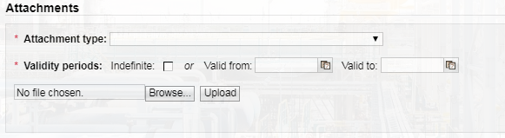

Figure 16

You should specify the validity of the added document. Set the flag “Indefinite”, if the file being added has an indefinite validity period, otherwise it is necessary to specify the beginning and end of the validity term of the document.

Next, you need to click on the "Browse" button. In the window that opens, select the file to attach. After selecting, you must click the “Upload” button. The size of each attached file should not exceed 30MB.

The result of the file application can be seen in this block.:

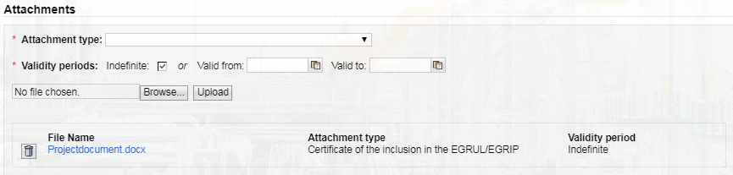

Figure 17

## Agreement to the storage and processing of my personal data

After filling out all the fields in the form, you have to read the terms of cooperation and agreement to the storage and processing of my personal data. If you agree with the policies and conditions, then you need to put a flag " I agree to the storage and processing of my personal data".

After that, it is possible to send the completed form to check the correctness of the data.

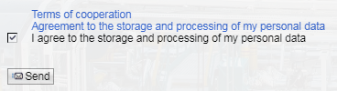

Figure 18

# Completion of supplier registration

If all the data is entered correctly, and the supplier agreed to the terms of cooperation and agreed to the wrapping and storage of personal data and the supplier clicked on the send button, a message appears on the screen:

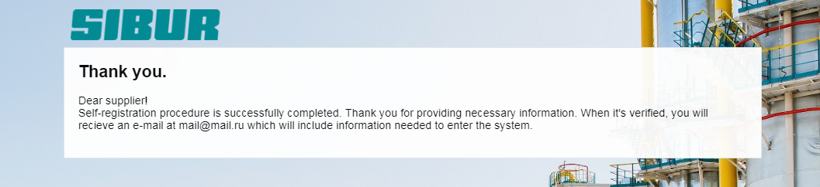

Figure 19

This message means that the request for registration in the Supplier Relationship Management system of PJSC SIBUR Holding has been sent for verification. Next, you need to wait for a response to the email address specified in the block "Contact Details".

In case of confirmation, data will be sent to enter the procurement system of PJSC SIBUR Holding. The letter contains a link to go to the system. After clicking on the link, you should enter the initial login and password, which are specified in the letter. After that you should enter a new username and a new password, which is further logged on.

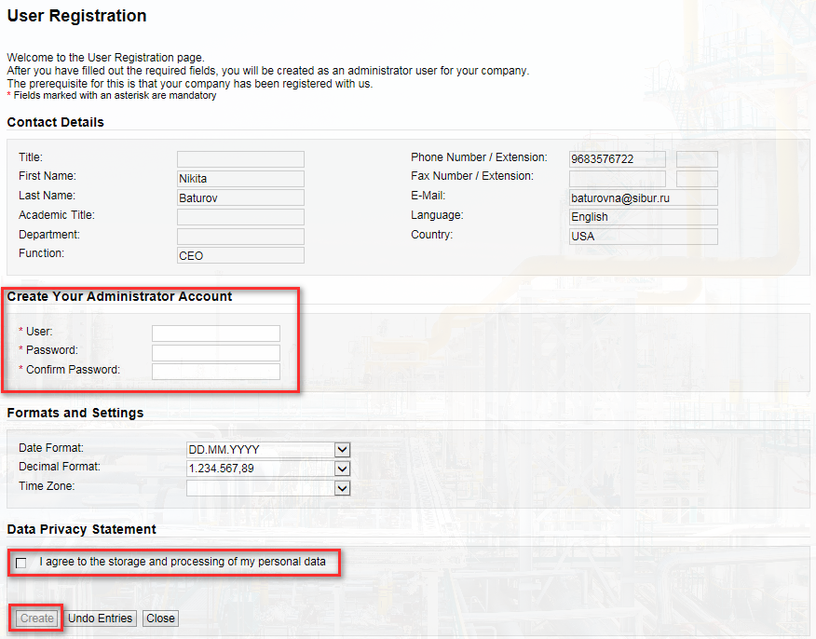

Figure 20

After setting the flag in the field "I agree to the storage and processing of my personal data." After clicking on the “Create” button, the main menu of the procurement system of PJSC SIBUR Holding opens.

And now, your administrator account has been successfully created. To continue your work in the SAP SRM system, please, click on «Log On»

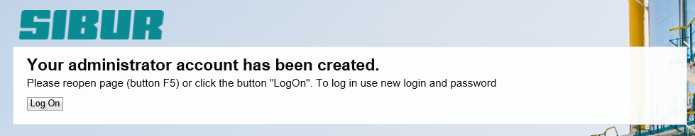

At this moment, system opened for you «Personal area supplier». Here you will be working in the SAP SRM system. You can save this link for your comfortable.

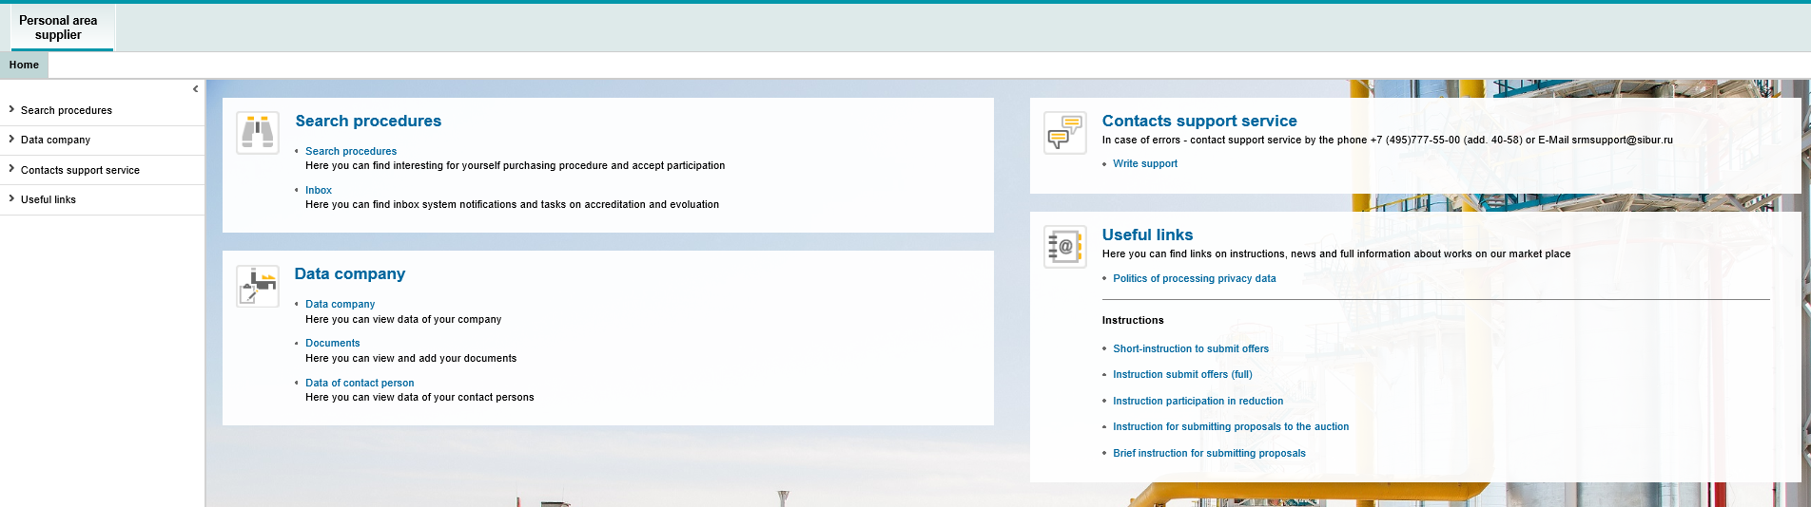

# Automatic password / login recovery

In case the user data for logging into the system have been lost, it is possible to automatically recover the login / password or password to the system. To recover your password, click on the “Forgot your password?” link on the login page.

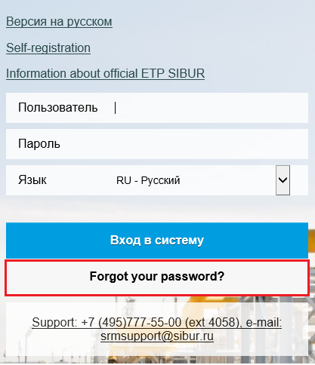

Figure 21

After clicking on the “Forgot your password?” link, a window will open in which you need to specify a password recovery method by email or login. In the field below, you should specify your email address, in case the login and password is lost, or specify the login, if only the password is lost. Click on the «Send» button.

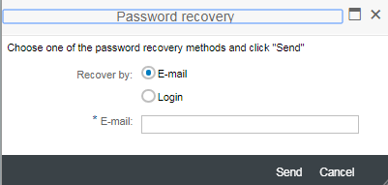

Figure 22

Then a message is displayed that the data has been sent to the user's email address. If the password was recovered by login, then new login data is sent to the email address specified during user registration.

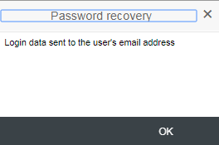

Figure 23

It is necessary to open the letter and follow the link. After that, a window will open to create a new password.

After entering the new password, you must click on the "OK" button. After that, the user will be able to log in with a new password.